**CSE3215**

**Quiz 3 (Set B2)**

**Time: 20 minutes**

**Marks: 10**

* 1. If your system is 3.3V and your 10-bit ADC is reporting 512, what is the analog voltage measured? (2)
  2. (3)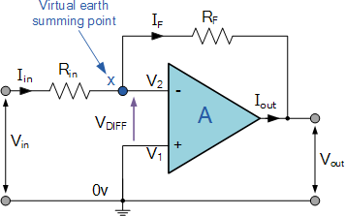

For the above figure, let RF = 350 kΩ, Rin = 20 kΩ and Vin = -0.75V. Calculate I, the voltage across RF and Vo.

* 1. A DAC is showing 4.2V output for the input code 101010. Calculate the LSB and Reference voltage if it operates within 2V to 12V. (2)
  2. What is Virtual Ground of an Inverting Amplifier? Explain with proof. (3)

Solution:

1. (a) : Analog Voltage Measured = 1.65V

(b): I= 0.0375 mA

Vref = 13.125V

Vout = 13.125V

2. (a) Vref = 6.402V LSB = 12/2^6 = 0.1875